EZ Park

EZPark Confidential | 2019

Written by

Shaista Usman

2019

Contents

1. Vision 2

2. Mission 2

3. Goal 2

4. In Scope 2

5. Out of Scope 2

6. Personas 3

7. Scenarios 4

8. UX Screens 5

9. Team Resources 6

10. Accrued Value 6

11. Backlog 6

12. Project History 12

13. Burn Down Chart 22

14. Peer review 22

**Vision**

EZ Park will be the easiest-to-use mobile application in the country which will make car parking hassle free and cheap.

**Mission**

To deliver a best in class and user-friendly car parking reservation system that can be used to locate and reserve parking spots before arrival.

**Goal**

Our goal is to develop a mobile application which helps users book parking spots in advance at places where finding available parking becomes challenging.

**Scope Definition**

**In scope:**

1. Mobile software application frontend which allows users to search, reserve, end and pay for a parking session.
2. The application will also allow users to look at their parking reservation history and save their favourite spots for quick use in future.
3. Parking reservation area included are airports, bus stations, railway stations, street parking, supermarkets, state parks, hotels in top 25 metro cities in USA.

**Out of scope:**

1. Car locating map that can help people walk and find their cars in the parking lot.
2. Currently a user can only book one spot at a time, eventually we want to have functionality to allow people to book parking spots for their friends and family as well.
3. In time we want to add functionally to have users book guest parking spots in apartment communities. Many times, guests have to come in and figure out where to park since there are no more guest spots left, with EZPark we will allow users to book spots in their own communities so that their guests do not have problems while visiting.
4. In the future we want to add functionality for users to waitlist on the spots at any place and once the spot is free it will get assigned on a first come first serve basis.
5. We also want to add a money wallet in the app for users to link their credit cards and bank accounts with, users can store money here and select if they want to use their cash back to pay for the reservation or just use the wallet balance.
6. Currently the mobile app is designed for the top 25 metro cities only, other cities are out of scope at the moment but we may launch it in the future.

**Persona**

Sarah Cooper

Sarah lives in Sammamish, WA with her husband, two children, ages 3 and 7 and her adopted French Bulldog “Marshmallow”. She is a real estate agent and hopes to be made a partner at her Seattle based firm in the near future. Her husband is a management consultant, and is always travelling to other states on business and is home only for the weekend. Sarah has a very busy schedule which involves meeting potential clients, organizing open houses, dropping off the kids to day-care, school and also running errands. Sarah feels that she wastes time travelling in and around the city for work assignments and the inability to find a parking spot aggravates her further. Life is chaotic at home and she is always looking to save time.

**Pain Points**

* Much time wasted looking for parking spots at malls and supermarkets when she could be doing something more crucial
* Paid parking lots in the city are not only expensive but also far from her office and street parking nearby is mostly occupied
* She has to regularly visit residential neighborhoods for work, and they have very few guest parking spots and parking becomes a hassle
* She feels she does not have enough quality time with her children
* She has limited free time

Eric Johnson

Eric lives in Bothell, WA with his girlfriend and works as an Engineering and Facilities Administrative Assistant at Target. Eric is also a drummist for the band “The Sailors” which he and his two friends from college started, a few years back. His band plays at the local pub on Saturdays. Eric has daily shifts of more than eight hours a day with various responsibilities. Eric hopes to be made manager someday and wants to learn and focus more on supply chain management and logistics of the company. He wishes that the mundane activities of his job like facilitating parking spots and keeping a check on parking occupancy took less time so he could work towards his professional goals.

**Pain Points**

* Customer parking validation for street parking is a tedious and time-consuming process
* The current process of identifying vehicles that exceed the admissible parking duration is manual and requires too much time and effort
* Eric is responsible for directing traffic to available parking spots during special sale events at Target, which is a quite arduous and requires him to be at the parking lot even in bad weather
* He wants to transition into a management role and wants to dedicate more time to the company’s accounts payable and receivable tasks

**Scenarios and features**

**Scenario: Using EZPark to reserve parking spots in advance**.

Sarah is a real estate agent and needs to travel frequently to meet with clients and attend local events related to real estate discussions. Sarah needs to reach downtown Seattle for a talk she has to deliver at a real estate conference and is running late because she had to drop her kids to school. To save time looking for a parking in downtown Seattle she wants to book a parking spot near her destination beforehand, Sarah downloads the EZPark App and on her mobile phone and opens the App. Sarah wants to login quickly through her Facebook account and clicks on the sign in with Facebook button on the homepage. She is then redirected to the page to enter her Facebook credentials, after clicking the submit button on this page she is successfully able to login. On the home page she is able to enter her destination address and search for parking spots nearby that location. After Sarah enters the address, she is asked for the duration for which she needs to park and a list of parking options nearby along with the prices for reserving each spot are given for her selection. Along with the search results, the app also gives her the option to sort the search results by price and distance to destination. She is able to scroll through the list and find a spot which is only a few meters away from her concerned destination. Sarah clicks on the reserve button right next to this search result and is directed to a page where she is asked to review the reservation duration and location followed by redirection to a payment gateway. After the payment is processed, she gets a QR code on the app. Sarah then reaches the parking spot she has reserved beforehand and scans the QR code in the EZ Park scanner located nearby. Once the QR code is scanned her parking session begins and is active till the duration she has booked the spot for, after her talk Sarah comes out and scans the QR code again in the scanner and that marks the end of her parking session. Using EZPark Sarah is able to save much time and use it to reach the event earlier and network with some people in the real estate industry. Moreover, it gives Sarah peace of mind before something important like delivering a talk instead of worrying about running late because of not being able to find a parking spot.

**Key features:** Facebook login, search for parking spots in destination, display real time availability of parking spaces, enter duration of parking, sort results by price and distance, advance reservations, online payments, QR code confirmation

**Scenario: Using EZPark to let out parking spots.**

Eric is an Engineering and Facilities Admin Assistant at the Seattle outlet of Target. Among other responsibilities, Eric is also responsible for managing the company’s parking facilities including carrying out parking validation and assisting customers in finding parking spots on extra busy days. This year during Black Friday he has been instructed by his supervisor to use EZPark and ensure smooth flow of cars in and out of the parking lot so that customers can spend more time inside the store than waste time looking for parking spots. To do this efficiently Eric opens the EZ Park App and is asked to create an account by entering his details, Eric enters all the required information like Login ID, Password etc., he then hits the submit button and is now set up as a user. After being logged in Eric is directed to a page where he is asked to enter information related to his business and the parking spots being let out. In this page he enters his business phone number, business email, duration for which the spots are being let out to be rented, number of spots being let out, city, zip code, option to upload photos of the spot and directions to the spot. After submitting such information, he receives a prompt that his information is being verified and he would receive a confirmation soon. Once Eric’s request is verified and approved, he receives a confirmation message on the app, and is directed to a page where he is asked to enter bank details where the parking rent is going to come in, Eric enters all required information like the bank account number, routing number and swift code and clicks the “Save account details” button. Now Eric’s business profile is set up and he is all set to let out the requested parking spots using EZPark and earn money for it. Using EZPark during Black Friday rush helped Eric let out spots for EZPark thereby reducing the time he would otherwise have to spend monitoring the parking lot. He was able to efficiently complete his supervisor’s request and that earned him recognition of being a smart-worker.

**Key features:** Create business profiles to let out parking spots, Link banking information to receive rent payments, Let out parking spaces for selected periods of time, Change the availability and rent price of spots, Add and remove parking spots from EZPark

**UX Screens**

Browse through parking options based on destination and schedule

Drive, arrive and park

Reserve and pay on the go

Scan the QR code received via message at the EZPark scanner

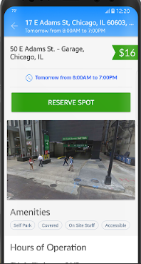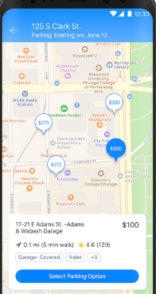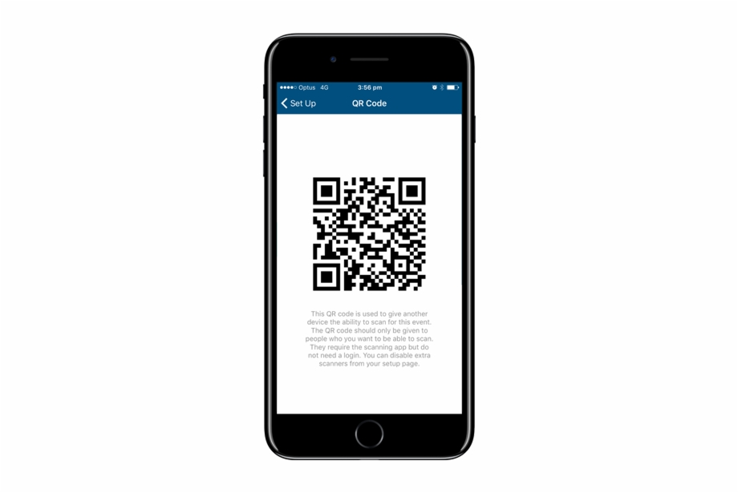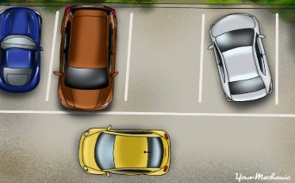

Schedule in advance

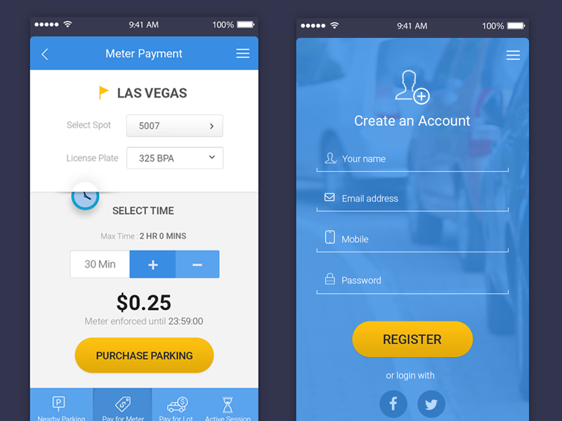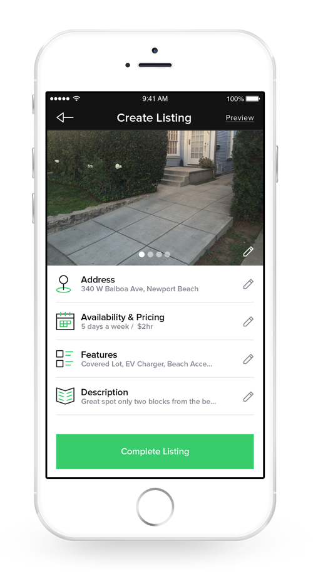

Apply to list parking space

Locate parking space using google maps

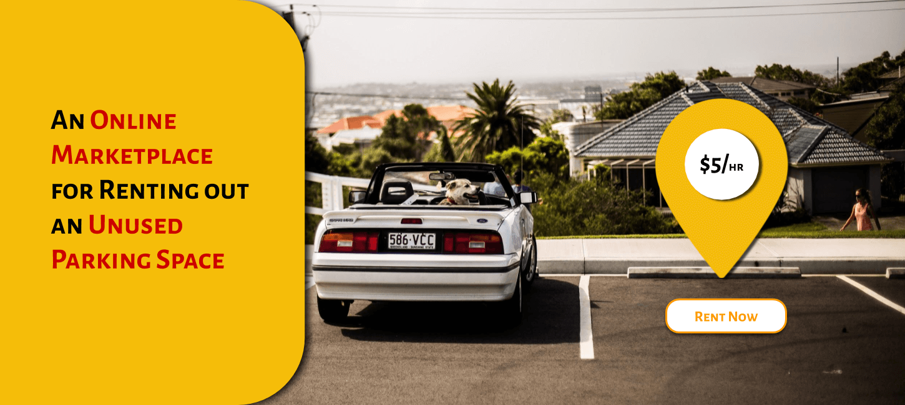

Provide additional information

Link banking account and rent out parking space

**Team Resources**

|  |  |  |
| --- | --- | --- |
| **Team member** | **Role** | **Experience** |
| Brian Todd | Software Developer | 4 years |
| Kirti Patel | Software Developer | 3 years |
| Andrew Lao | Software Developer | Beginner |
| Paul Pei | Software Developer | Beginner |
| Brenda Jones | Scrum Master | 5 years |
| Shaista Usman | Product owner | 3 years |

**Accrued value and Backlog**

Accrued value

* Search and schedule parking spaces for selected intervals of time
* Make online payments
* Sort parking spaces by distance
* Receive confirmation alerts and reminders
* Let out parking spaces
* Leave comments and feedback
* Login with Google and Facebook account

|  |  |  |  |
| --- | --- | --- | --- |
| **Stack Rank** | **User Stories** | **Acceptance criteria** | **Rough point assignments** |
|  | “As Sarah, a user with parking needs, I want to be able to see a message if I searched for a location where parking services are already full.” | • Ensure the location entered is correct and exists  • Ensure there are no available spots at the location  • Ensure that the user gets prompt that currently no parking spots are available at this location   * Ensure that the user is able to see the search bar | 5 |
|  | “As Sarah, a user with parking needs, I want to be able to reserve the spot I have selected. ” | * Ensure that the user is able to view the Reserve button against every available parking option * Ensure that the user gets redirected to the Payment page by clicking the reserve button | 5 |
|  | "As Eric, a user who wants to let out parking spaces, I want ensure password security account is locked after three failed login attempts" | * Ensure that after three failed attempts to login by the user having a registered username, user account gets locked * Ensure an account locked message is prompted to the user | 3 |
|  | "As Eric, a user who wants to let out parking spaces, I want to be able to sign up with my basic details." | * Ensure the user is able to enter first name * Ensure the user is able to enter last name * Ensure the user is able to enter contact no * Ensure the user is able to enter email * Ensure the Fist name and last name fields take only characters * Ensure the Fist name and last name fields take no more than 15 characters each * Ensure the contact No field take only numeric characters * Ensure the contact No field takes exactly that 10 characters * Ensure the email Id field takes no more than 15 characters * Ensure the email Id field takes no special characters except @ * Ensure the email Id field takes exactly one @ character * Ensure the email Id field takes exactly at least one character | 8 |
|  | “As Sarah, a user with parking needs, I want to be able to get a QR code so that I can use it to track my parking session.” | * Ensure the user receives a unique QR code on the app once the payment for the booked spot has been completed * Ensure that QR code maps on to the user’s account * Ensure that QR code maps on to the user’s account * Ensure that QR code maps on to the booked parking spot | 5 |
|  | “As Sarah, a user with parking needs, I want to be able to change the time intervals to find parking options at different time periods.” | * Ensure that the user can change the values in the "from" and "to" fields by clicking on them * Ensure that on clicking on the drop down at the "from" and "to" fields, the user is given a list of time periods * Ensure the user is able to select only one value for both from and to fields * Ensure the user cannot select the same time for both the to and from fields * Ensure the user is not able to select a past time for both from and to fields | 5 |
|  | “As Sarah, a user with parking needs, I want to be able to sort the available parking options based on distance from my destination." | * Ensure the user is able to locate a drop down on the find parking page * Ensure the user has ‘sort by distance’ as one of the options on the drop down | 2 |
|  | “As Sarah, a user with parking needs, I want to be able to cancel a booked spot." | * Ensure the user is able to locate a cancel button alongside the listed reservation on the upcoming Reservations panel * Ensure that on clicking on the cancel button, the user’s reservation effectively ends * Ensure that the concerned reservation listing is no longer visible on the upcoming Reservations panel | 5 |
|  | "As Eric, a user who wants to let out parking spaces, I want to be able to sign up with EZ Park on the app so that I can let out parking spots." | * Ensure the user is able to find the sign-up button on the home screen within the account panel * Ensure the user gets redirected to the Sign-Up Screen | 3 |
|  | "As Eric, a user who wants to let out parking spaces, I want to be able to know when my account has been rejected so I can apply again." | • Ensure the user gets a prompt on the app on opening the app if the users’ details were incorrect and could not be verified | 2 |
|  | “As Sarah, a user with parking needs, I want to be able to get a cancellation confirmation on making a cancellation." | * Ensure the user receives a cancellation confirmation prompt on the app once the spot has been cancelled | 2 |
|  | "As Eric, a user who wants to let out parking spaces, I want to be able to view all the spots that I am currently letting out on EZPark.” | * Given the user is logged in from a business account * Ensure the user is returned a list of the parking spots that are currently being rented out by them when the user hits the Edit Parking button | 3 |
|  | “As Sarah, a user with parking needs. I want to check out as guest if I do not want to create an account” | * Ensure the user does not have an account set up * Ensure the user is able to locate a “checkout as guest” icon on the on the Reservations screen * Redirect to the payment gateway when user clicks the “checkout as guest” | 5 |
|  | “As Sarah, a user with parking needs, I want to be able to login to my account and check out my past parking spots so I can book them quickly without searching every time." | * Given the user is on the Favorites screen " * Ensure all the listings on the favorites page have a Reserve again button * Ensure the user gets redirected to the "Reservation" Screen, if the spot is available. | 5 |
|  | “As Sarah, a user with parking needs, I want to be able to get answers to some of my basic queries in less time  and without having to contact Customer Service." | * When the user scrolls down to “Support” panel at the bottom of the home Screen * Then ensure the user is able to: * See the “FAQ” icon on the support panel * See a list of frequently asked questions and their answers on the FAQ Screen | 5 |
|  | "As Eric, a user who wants to let out parking spaces, I want to be able to view the EZPark's policies on payments,  cancellations, subscriptions, refunds and licensor terms and conditions before I register my company's parking spaces." | * When the user scrolls down to “Support” panel at the bottom of the home Screen * Then ensure the user is able to: * See the “Terms and Conditions” icon * See the list of EZPark’s terms, conditions, policies and other such details | 3 |
|  | “As Sarah, a user with parking needs. I want to save parking my favorite parking locations, so I can find them easily” | * Ensure the user is able to locate a save button on the Reservations page * Ensure that the spot is visible on the Favourites screen | 2 |
|  | “As Sarah, a user with parking needs, I want to be able to get a confirmation on successfully making a parking reservation." | * Ensure the user receives a confirmation prompt on the app once the payment for the booked spot has been completed | 2 |
|  | “As Sarah, a user with parking needs. I want to be able to view the details of my current reservations” | * Given the user is on the Upcoming Reservations screen * Ensure the current reserved spot is listed here * Ensure the address of the spot is also displayed * Ensure the schedule of the reservation for the spot is also displayed | 2 |
|  | "As Eric, a user who wants to let out parking spaces, I want to be able to add parking spots for rent to my current listings" | * Given the user is logged in from a business account and on the Edit Parking Screen * Ensure the user is able to see a “add” button near every listing corresponding to his/her rented out spots * Ensure that on clicking the “add” button the number of spots for the parking space increments by one | 3 |
|  | “As Sarah, a user with parking needs. I want to see other user testimonials in the Home page so that I know what opinion other users have about this app” | * Ensure two testimonials are displayed on the home page * Ensure the user’s name is displayed * Ensure displayed testimonials have such keywords ‘love’, ’like’, ‘great’, ‘best’, ’useful’ etc * Ensure displayed testimonials do have such keywords ‘hate’ ‘bad experience’, ‘worst’ etc. | 3 |
|  | “As Sarah, a user with parking needs. I want to submit my testimonial in the EZPark app” | * Get redirected to the “Testimonials” Screen on clicking on the “Testimonials” button within the support panel * Enter the following details “Full Name”, “Email”, “Contact Number” and “Message” in separate text fields * Ensure the name field accepts only Alphabets and spaces and no characters * Ensure the Contact Number field accepts only numerical values * Ensure the Email Field accepts in the format abc@email.com * Ensure that the Message field does not accept more than 300 characters * Submit the entered details by clicking on the “Send Message” button" | 5 |
|  | “As Sarah, a user with parking needs. I want to have push notifications on my parking session” | * Display settings icon on the top right of the page * Ensure “Notifications” is visible on clicking the settings tab * Provide the option “Turn on push notifications” when a user clicks the notification button | 3 |
|  | “As Sarah, a user with parking needs. I want to be able to view a photograph of the available spots as a reference in order to make my decision.” | * Ensure the user is able to see a small sized photograph of the listed spot alongside the available spot on the Reservations page | 3 |
|  | "As Eric, a user who wants to let out parking spaces, I want to see ratings given by users to my parking spots" | * Ensure the user is able to see the average ratings as star ratings given for the spots on alongside the available spot list | 3 |
|  | "As Eric, a user who wants to let out parking spots, I want to be able to connect with the Application's  Facebook account so that I can advertise my parking spaces." | * Ensure the user is able to see the Facebook icon on the connect with us panel * Ensure the user gets redirected to EZPark’s Facebook page | 3 |
|  | "As Eric, a user who wants to let out parking spots, I want to be able to connect with the Application's  Twitter account so that I can advertise my parking spaces." | * Ensure the user is able to see the Twitter icon on the connect with us panel * Ensure the user gets redirected to EZPark’s Twitter page | 3 |

___________________________________________________________________________________

**Project History –** **User Stories for each sprint and backlog**

**Sprint 1 Summary:**

* Number of items completed - 6
* Total Story Points Estimated - 18
* Total Completed - 13
* Velocity Team - 13
* Velocity per developer
* Brian Todd - 5
* Kirti Patel - 4
* Andrew Lao - 2
* Paul Pei - 2

|  |  |  |  |  |  |
| --- | --- | --- | --- | --- | --- |
| **ID** | **Title** | **Acceptance** | **Dev** | **Points** | **Actuals** |
| 1 | “As Sarah, a user with parking needs, I want to be able to search for available parking spots by simply typing in a location." | * Ensure that the user is able to locate the search bar on the home screen * Ensure that the user is able to type in her destination * Ensure that the user does not type in more than 90 characters | Andrew Lao | 1 | 2 |
| 2 | “As Sarah, a user with parking needs, I want to be able to see the results of my search." | * Ensure the location entered is correct and exists * Ensure that parking services are available at the location entered * Ensure there are available spots at the entered location, starting from the current timestamp and the current date by default * Redirect page to Find Parking page | Brian Todd | 3 | 3 |
| 3 | “As Sarah, a user with parking needs, I want to be able to login to my account." | * Ensure that the user is able to locate the My account panel on the home screen * Ensure that the user gets redirected to the login screen on selecting the My account panel | Brian Todd | 2 | 2 |
| 4 | “As Sarah, a user with parking needs, I want to be able to log in to EZPark with my Facebook account." | * Ensure that the user is able to locate the Facebook icon on the Login Page screen * Ensure that the user gets redirected to the Facebook login page on clicking the Facebook icon * Ensure that the user has a valid Facebook account * Ensure that the user gets connected to EZPark with a valid Facebook account | Paul Pei | 2 | 2 |
| 5 | “As Sarah, a user with parking needs, I want to be able to enter a strong password when creating my account." | * Ensure the user is able to locate the password field on the login screen * Ensure password is a text field * Ensure password must have at least 8 characters * Must contain at least 1 digit * Must contain at least 1 uppercase letter * Must contain at least 1 lowercase letter * Must contain at least 1 symbol | Kirti Patel | 1 | 2 |
| 6 | "As Eric, a user who wants to let out parking spaces, I want to automatically receive rent on the spots I have let out." | * Ensure that the user is able to locate the Link Bank and Earn icon on the Rent Out panel * Ensure that the user gets redirected to the Link Banking details screen on selecting the Link Bank and Earn icon | Kirti Patel | 2 | 2 |

**Sprint 2 Summary:**

* Number of items completed - 8
* Total Story Points Estimated - 13
* Total Completed - 13
* Velocity Team - 13
* Velocity per developer
* Brian Todd - 5
* Kirti Patel - 4
* Andrew Lao - 2
* Paul Pei - 2

|  |  |  |  |  |  |
| --- | --- | --- | --- | --- | --- |
| **ID** | **Title** | **Acceptance** | **Dev** | **Points** | **Actuals** |
| 1 | “As Sarah, a user with parking needs, I want to be able to see a message if I searched for a location where parking services are unavailable. “ | • Ensure the location entered is correct and exists  • Ensure that parking services are not available at the location  • Ensure that the user gets prompt that currently EZPark does not service this location  • Ensure that the user is able to see the search bar | Brian Todd | 2 | 2 |
| 2 | “As Sarah, a user with parking needs, I want to be able to log in through my Google account." | * Ensure that the user is able to locate the Google icon on the Login Page screen * Ensure that the user gets redirected to the Google login page on clicking the google icon * Ensure that the user has a valid Google account   Ensure that the user gets connected to EZPark with a valid google account | Kirti Patel | 1 | 1 |
| 3 | “As Sarah, a user with parking needs, I want to be able to contact customer support center to give my feedback and put forth my queries." | • Ensure the user gets redirected to the “Contact Us” Screen on clicking on the “Contact Us” icon within the support panel  • Ensure EZPark’s phone number for Customer Service is displayed  • Ensure the functioning hours and availability for Customer Service is displayed  • Ensure the user is able to enter the following details “Full Name”, “Email”, “Contact Number” and “Message” in separate text fields  • Ensure the name field accepts only Alphabets and spaces and no characters  • Ensure the Contact Number field accepts only numerical values  • Ensure the Email Field accepts in the format abc@email.com  • Ensure that the Message field does not accept more than 300 characters  • Submit the entered details by clicking on the “Send Message” button" | Kirti Patel | 3 | 3 |
| 4 | “As Sarah, a user with parking needs, I want to be able to see the parking option available at my entered location.” | * Ensure the parking spot available in the exact location entered by the user is displayed | Brian Todd | 1 | 1 |
| 5 | “As Sarah, a user with parking needs, I want to be able to login to my account using my EZPark credentials." | * Ensure the user can enter his/her username and passwords in text fields * Ensure the entered username is registered with EZPark * Ensure the user has entered a correct password for the username * Ensure the user gets logged in with his/her user account profile | Brian Todd | 2 | 2 |
| 6 | “As Sarah, a user with parking needs, I want to be able to see the rent price of the result.” | * Ensure that the user is able to view the price for the displayed parking spot for the default time interval of an hour | Andrew Lao | 1 | 1 |
| 7 | “As Sarah, a user with parking needs, I want to be able to know that I entered incorrect login credentials.” | * Ensure the user gets a prompt for an invalid username entered * Ensure the user gets a prompt for a wrong password entered for an existing account | Andrew Lao | 1 | 1 |
| 8 | “As Sarah, a user with parking needs, I want to be able create and save my account so I can log in later." | * Ensure the user is able to locate the username field on the sign-up screen * Ensure username is a text field * Ensure username must have at least 5 characters * Ensure username entered is not already taken * Ensure username must have not more than 10 characters * Ensure the user has entered a password * Ensure that the user’s credentials get saved on hitting “Save” | Paul Pei | 2 | 2 |

**Sprint 3 Summary:**

* Number of items completed - 5
* Total Story Points Estimated - 13
* Total Completed - 13
* Velocity Team - 13
* Velocity per developer
* Brian Todd - 5
* Kirti Patel - 4
* Andrew Lao - 2
* Paul Pei – 2

|  |  |  |  |  |  |
| --- | --- | --- | --- | --- | --- |
| **ID** | **Title** | **Acceptance** | **Dev** | **Points** | **Actuals** |
| 1 | "As Eric, a user who wants to let out parking spaces, I want users of EZPark to locate my parking spaces." | •Ensure the user is able to enter the address  •Ensure the user cannot enter more than 75 characters for address  •Ensure the user cannot enter more than 75 characters for address  •Ensure the user enters not less than 30 characters for address  •Ensure the user is able to enter the state  •Ensure the user does not enter a non-existing state  •Ensure the user is able to enter the city  •Ensure the user does not enter a non-existing city within the state entered  •Ensure the user is able to enter the zip  •Ensure the entered the zip has only 5 digits  • Ensure the user is able to enter the number of spots  • Ensure the user is able to enter only numerical values for number of spots  • Ensure the user is cannot enter a value greater than 30 for number of spots  • Ensure the user is able to enter the price  • Ensure the user is able to enter only numerical values for the price  • Ensure the user is able to enter only 3 digits for the price | Brian Todd | 3 | 5 |
| 2 | "As Eric, a user who wants to let out parking spaces, I want to be able to register my business account so I can start renting spaces." | • Ensure the user has entered all the fields in the “Rent Out” screen  • Ensure none of the fields have error codes  • Ensure the user is able to locate the “Let Out” icon  • Ensure on selecting the “Let Out” icon, all the user’s details get saved  • Ensure the user gets a prompt that EZPark is verifying submitted details and will get back in a few days | Kirti Patel | 3 | 3 |
| 3 | "As Eric, a user who wants to let out parking spaces, I want to be able to know when my account has been verified so I can start renting spaces." | • Ensure the user gets a prompt on the app on opening the app once the user’s business account has been verified  • Ensure a business profile is created for the user | Kirti Patel | 1 | 1 |
| 4 | "As Eric, a user who wants to let out parking spaces, I want to be able to edit the rent on the parking spots I let out." | • Ensure that the user is able to see "price" field on the Edit parking screen  • Ensure the user is able to enter the price  • Ensure the user is able to enter only numerical values for the price  • Ensure the user is able to enter only 3 digits for the price | Paul Pei | 2 | 2 |
| 5 | "As Eric, a user who wants to let out parking spaces, I want to be able to edit the availability of my parking spaces periodically." | Given the user is logged in a from a business account  • Ensure the user is able to find the Edit Parking button on the home screen within the account panel  • Ensure the user gets redirected to the Edit Parking Screen | Andrew Lao | 2 | 2 |

**Sprint 4 Summary:**

* Number of items completed - 6
* Total Story Points Estimated - 10
* Total Completed - 9
* Velocity Team - 10
* Velocity per developer
* Brian Todd - 1
* Kirti Patel - 4
* Andrew Lao - 2
* Paul Pei – 2

Brian had planned leaves for four days in this week and so the estimated story points for the team was less than usual to accommodate his absence.

|  |  |  |  |  |  |
| --- | --- | --- | --- | --- | --- |
| **ID** | **Title** | **Acceptance** | **Dev** | **Points** | **Actuals** |
| 1 | "As Eric, a user who wants to let out parking spaces, I want to be able to let out parking spots for selected dates." | • Ensure that the user is able to see a drop-down arrow in the "from date" and "to date" fields Edit parking screen  • Ensure that the user can change the values in the "from" and "to" fields by clicking on them  • Ensure that on clicking on the drop down at the "from" and "to" fields, the user is able to view a calendar  • Ensure the user is able to select only one value for both from and to fields  •Ensure the user is not able to select a past date for both from and to fields  • Ensure the user is not able to select a date 3 months from the current date for both from and to fields | Kirti Patel | 3 | 3 |
| 2 | “As Sarah, a user with parking needs, I want to be able to see all the parking options available near my entered location.” | • Ensure all the locations are displayed as a list  • Ensure all the spots displayed are near a 5-mile radius of the location entered by the user  • Ensure the user can scroll through all the available options  • Ensure all the locations displayed available on the current date and for an interval of an hour from the current time by default | Kirti Patel | 1 | 1 |
| 3 | “As Sarah, a user with parking needs, I want to be able to make an online payment for my reserved spot." | • Ensure that the user is able to see the "Pay in advance" button under the payment tab on the Payment page  • Ensure the user gets redirected to the banking payment gateway | Brian Todd | 1 | 1 |
| 4 | “As Sarah, a user with parking needs, I want to be able to view parking options available for different time intervals that I have selected.” | • Ensure that the user gets a list of available parking options within the selected date and time periods | Paul Pei | 1 | 1 |
| 5 | “As Sarah, a user with parking needs, I want to be able to know that no parking options are available for time intervals that I have selected.” | • Ensure a message "Not Found" is displayed if no parking options are available in the selected time interval and date | Paul Pei | 1 | 1 |
| 6 | “As Sarah, a user with parking needs, I want to be able to review my reservation details before making a payment." | • Ensure that the user is able to see the start date, time for the reservation under the "Review Reservations" tab on the Payment page  • Ensure that the user is able to see the end date, time for the reservation under the "Review Reservations" tab  • Ensure that the user is able to see the reservation price under the "Review Reservations" tab | Andrew Lao | 2 | 2 |

**Sprint 5 Summary:**

* Number of items completed - 5
* Total Story Points Estimated - 13
* Total Completed - 11
* Velocity Team - 11
* Velocity per developer
* Brian Todd - 5
* Kirti Patel - 1
* Andrew Lao - 2
* Paul Pei – 2

Kirti was out sick for three days and was able to work and complete one user story out of the three user stories assigned to her.

|  |  |  |  |  |  |
| --- | --- | --- | --- | --- | --- |
| **ID** | **Title** | **Acceptance** | **Dev** | **Points** | **Actuals** |
| 1 | “As Sarah, a user with parking needs, I want to be able to view the dates on which the parking spots are available.” | • Ensure that the user is able to see a "from date" and "to date" fields  • Ensure that the user is able to see the dates the parking options are available for in the ‘from’ and ‘to’ bars  • Ensure that by default the "from" and "to" field displays the current date by default | Paul Pei | 2 | 2 |
| 2 | “As Sarah, a user with parking needs, I want to be able to view the time intervals for which the parking spots are available.” | • Ensure that the user is able to see a "from time" and "to time" fields  • Ensure that the user is able to see the time the parking options are available for in the ‘from’ and ‘to’ bars  • Ensure that by default the "from" field displays the current timestamp  • Ensure that by default the "to" field displays a time, an hour from the current time | Andrew Lao | 2 | 2 |
| 3 | "As Eric, a user who wants to let out parking spaces, I want to be able to let out parking spots for selected periods of time." | • Ensure that the user is able to see "from" and "to" fields on the Edit parking screen  • Ensure that the user is able to see a drop-down arrow in the "from time" and "to time" fields  • Ensure that the user can change the values in the "from time" and "to time" fields by clicking on them  • Ensure that on clicking on the drop down at the "from" and "to" fields, the user is given a list of time periods  • Ensure the user is able to select only one value for both from and to fields  • Ensure the user cannot select the same time for both the to and from fields  • Ensure the user is not able to select a past time for both from and to fields | Brian Todd | 3 | 3 |
| 4 | “As Sarah, a user with parking needs, I want to be able to change the dates to find parking options at other and different dates.” | • Ensure that the user is able to see a drop-down arrow in the "from date" and "to date" fields  • Ensure that the user can change the values in the "from" and "to" fields by clicking on them  • Ensure that on clicking on the drop down at the "from" and "to" fields, the user is able to view the calendar  • Ensure the user is able to select only one value for both from and to fields  • Ensure the user is not able to select a past date for both from and to fields  • Ensure the user is not able to select a date 3 months from the current date for both from and to fields | Brian Todd | 2 | 2 |
| 5 | “As Sarah, a user with parking needs, I want to be able to view the available parking spots the location I searched for." | • Ensure that the user's search returns a list of available spots | Kirti Patel | 1 | 1 |

**Sprint 6 Summary:**

* Number of items attempted - 6
* Total Story Points Estimated - 13
* Story Points per developer
* Brian Todd - 5
* Kirti Patel - 4
* Andrew Lao - 2
* Paul Pei - 2

|  |  |  |  |  |  |
| --- | --- | --- | --- | --- | --- |
| **ID** | **Title** | **Acceptance** | **Dev** | **Points** | **Actuals** |
| 1 | “As Sarah, a user with parking needs, I want to be able to see an error message if I searched for an incorrect location." | • Ensure the user is given a prompt that the entered location was not found and should try again  • Ensure that the user is able to go back to the search bar  • Ensure the location entered is incorrect and does not exist | Andrew Lao | 2 |  |
| 2 | "As Eric, a user who wants to let out parking spaces, I want to be able to link my banking details so I can potentially receive rent on the spots I have let out" | • Ensure the user can enter his/her address within a text field  • Ensure the user cannot enter more than 75 characters for address  • Ensure the user enters not less than 30 character for address  • Ensure the user is able to enter the state within a text field  • Ensure the user does not enter a non-existing state  • Ensure the user is able to enter the city within a text field  • Ensure the user does not enter a non-existing city within the state entered  • Ensure the user is able to enter the zip  • Ensure the entered zip has only 5 digits  • Ensure the user is able to enter the Name on account within a text field  • Ensure the entered Name on account has only alphabets  • Ensure the entered Name on account does not have less than 5 characters  • Ensure the entered Name on account does not have more than 20 characters  • Ensure the user is able to enter the SWIFT Code  • Ensure the entered SWIFT Code has no special characters  • Ensure the entered SWIFT Code has 11 characters  • Ensure the user is able to enter the Account number  • Ensure the entered Account number accepts only numeric values  • Ensure the entered Account number has 10 to 12 digits  • Ensure the user is able to enter the Routing number  • Ensure the entered Routing number has 9 digits  • Ensure the entered Routing number accepts only numeric values | Brian Todd | 5 |  |
| 3 | "As Eric, a user who wants to let out parking spaces, I want to be able to login such that my existing business profile with EZPark gets loaded" | * Ensure the entered username on the login screen is registered with EZPark * Ensure the user has entered a correct password for the username * Ensure the username corresponds to a valid business account * Ensure the user gets logged in with his/her business profile * Ensure the user has access to view “My Parking Spaces” Page * Ensure the user has read and write access to “My business account” Page | Kirti Patel | 3 |  |
| 4 | "As Eric, a user who wants to let out parking spaces, I want to be able to remove the parking spaces I am letting out." | • Given the user is logged in from a business account and on the Edit Parking Screen  • Ensure the user is able to see a “Remove” button near every listing corresponding to his/her rented out spots  • Ensure that on clicking the “Remove” button the concerned spot is removed from the list of spots available for parking | Paul Pei | 2 |  |
| 5 | “As Sarah, a user with parking needs, I want to be able to be alerted in case my reservation did not go through." | * Ensure the user receives a prompt on the app if the payment for the booked spot was not completed | Brian Todd | 1 |  |
| 6 | “As Sarah, a user with parking needs, I want to be able to see the sorted list of the available parking options based on distance from my destination on selecting ‘sort by distance’." | • Ensure the available parking spots are displayed as a sorted list by distance when the user selects ‘sort by distance’ option  • Ensure the available parking spots are listed in increasing order of their distances from the user’s destination | Kirti Patel | 1 |  |

**Burndown Chart**

**Peer review**

Peer review from – Michael Arvin, Nishigandha Mhatre, [Sai Lavanya Kanakam](https://seattleu.instructure.com/courses/1587061/users/6206430)

Peer review given for – Scrub and Save, MissionAlpha